# 6U 550MM 19" DATA WALL CABINET - BLACK | 6U RACK CABINET

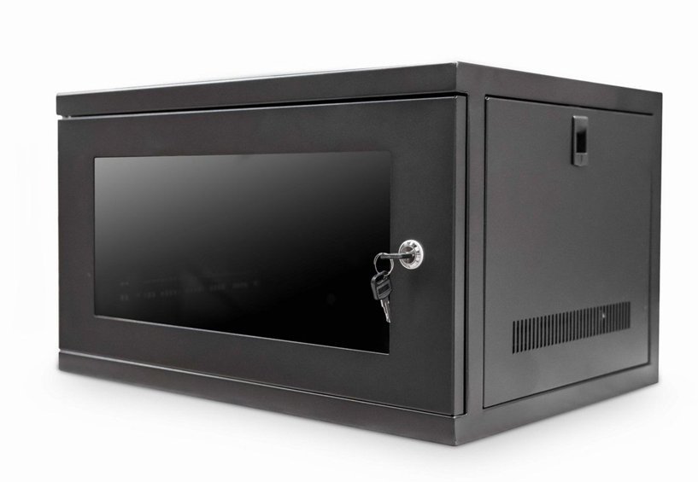

# Descrption:

**Your ideal enclosure for small-scale networking and PBX deployment 6U Rack Cabinet**  
  
Offering 6U Rack Cabinet advanced design features for your wall-mount enclosures for all your networking projects.  
  
The LMS Data EcoNetCab range of wall enclosures offer outstanding value  
for money coupled with superior build quality and a host of features to make  
pre and post-installation easier with reduced installation time.  
  
Available from**6U** to **21U** in a range of depths/widths and allow easy fitment  
to a range of wall constructions. Security is paramount to the range and all  
enclosures come with front, lockable left/ right hinged door together with  
removable side panels for easy post maintenance procedures and universal-fit  
19” uprights for all your active and passive devices.

# SPECIFICATIONS:

ETSI 19” front/rear profiles (adjustable)

Lockable glass door and removable sides

Wall mountable, RAL 9005

# TECHNICAL INFO:

SKU/MPN:  CAB-W6U-EL550  
EAN: 8400800016140  
Weights: 11.5Kg  
Dimensions: 550x550x320

# FILES

[Datasheet - CAB-W6U-EL550](https://cdn.shopify.com/s/files/1/0071/2337/0043/files/LMS_Data_EcoNetCab_Wall_Enclosures_V1_0_2_1e583575-130d-4744-bc2f-6319ba34ce22.pdf?51)